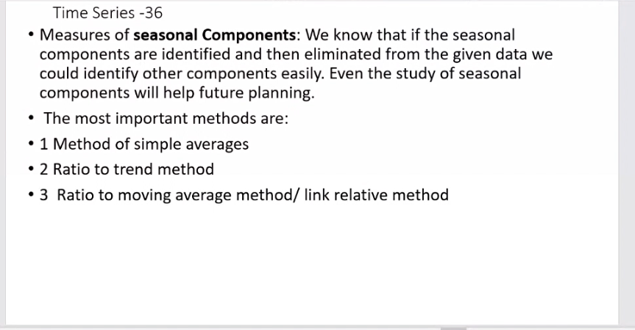

2. -> for seasonal index.

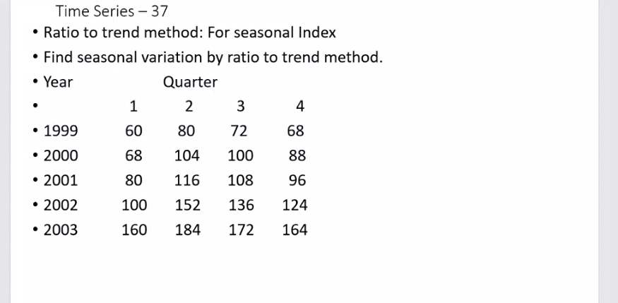

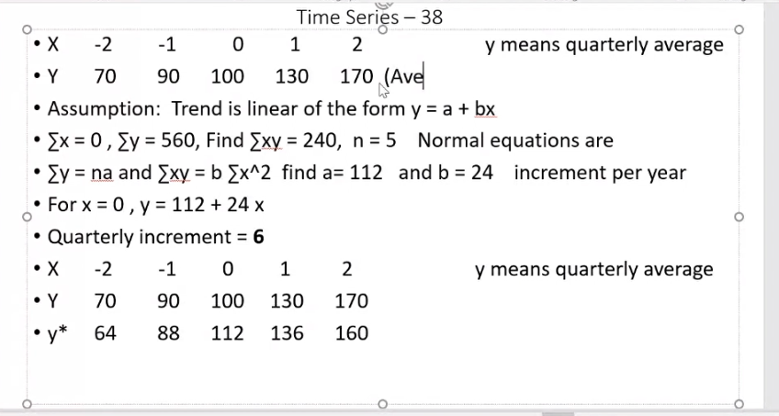

Y is average of all quarters of the year

quarterly increment -> b/4

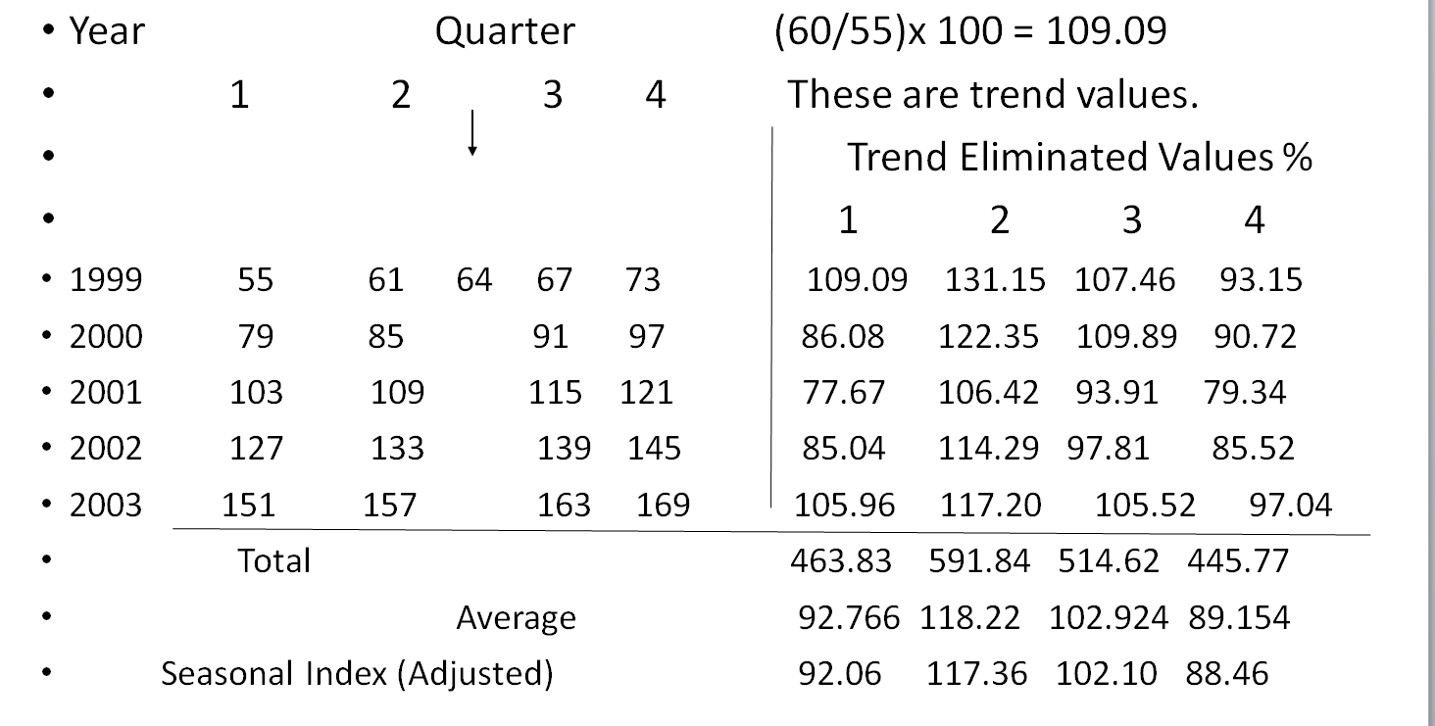

?? Here, 64 is the value of Y\* in year 1999 -> predicted value for 1st july

Finding Trend Eliminated % values:

109.09 -> 60/55\*100 -> original value/obtained value X 100

Average = avg of column/ quarter

Adjusted seasonal -> find the average of average = grand average = 100.78

Then correction factor, CF = 100/grand average = .992

Seasonal index = CF\*Average

For verification -> add seasonal indices, = 400. Must be 400. If CF not applied, answer would be graeater than 400.

These seasonal indices/factors have been derived using multiplicative model of the time series. i.e, assuming original data is in multiplicative model

/////Ignoree

// predicted quarters

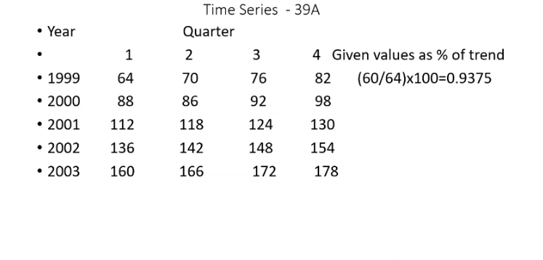

//////////////////

// another ques

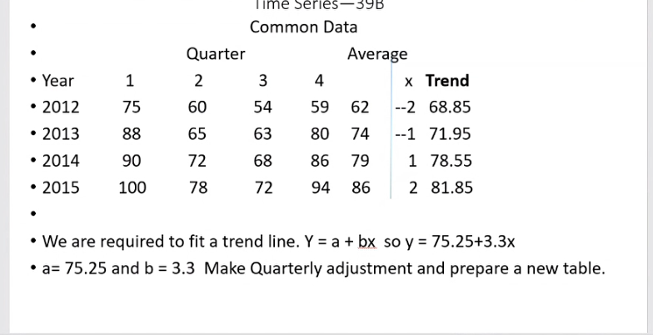

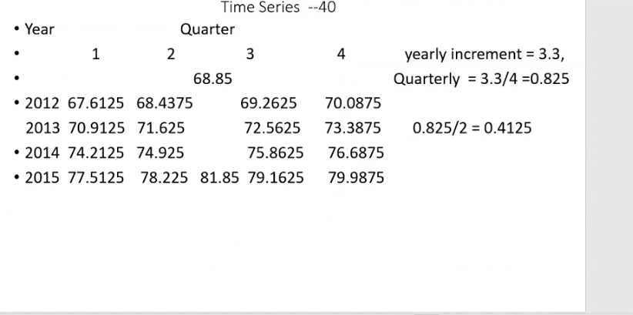

Additive model method:

Do everything till before taking ratios

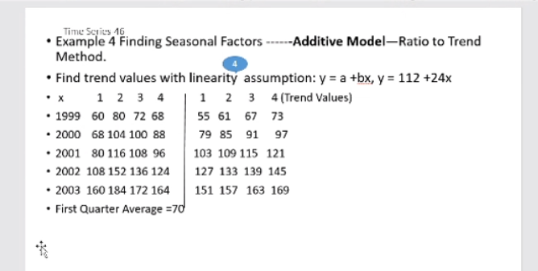

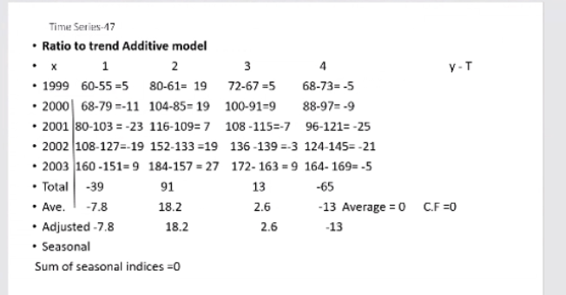

Find total, average, correction factor, and get seasonal indices = avg – CF

CF = average of average values

Sum of seasonal indices = 0

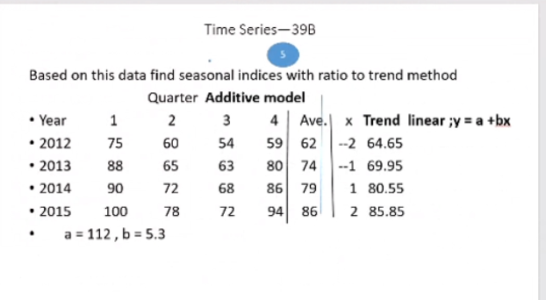

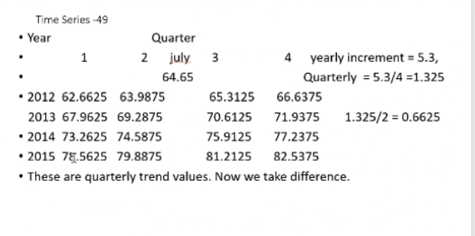

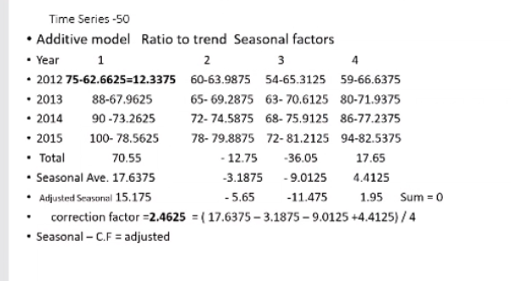

Ratio to moving average:

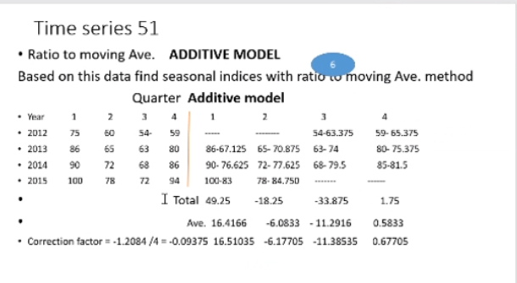

Link relative method

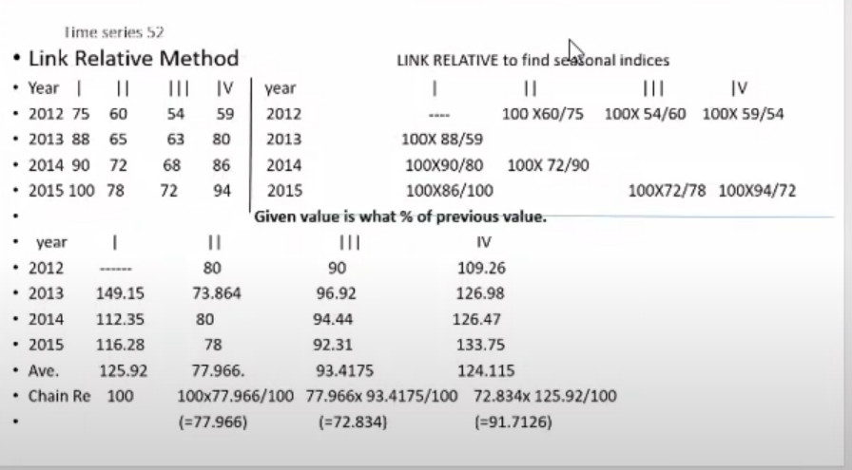

Find percentages of today than yesterday ( right above table shows calculation, table below its result)

I.e. given value is what percentage of previous values

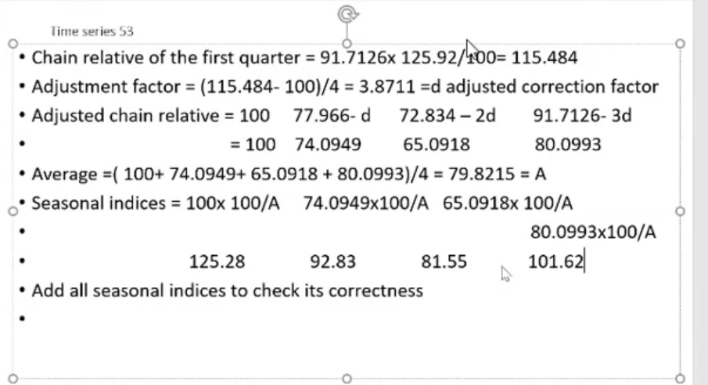

Sum of seasonal = 400

1. Make the table..
2. Find the averages (/3 for first, /4 for others)
3. Take chain relative -> Multipliy current avg/100 with last chain relative
4. Find chain relative to first quarter again
5. Find adjustement factor
6. And ahjusted chain relative
7. Take avg of above factors. -> A
8. 100/A = Correction factor..
9. Seasonal indices = CF \* adj chain relative

Method of seasonal averages:

